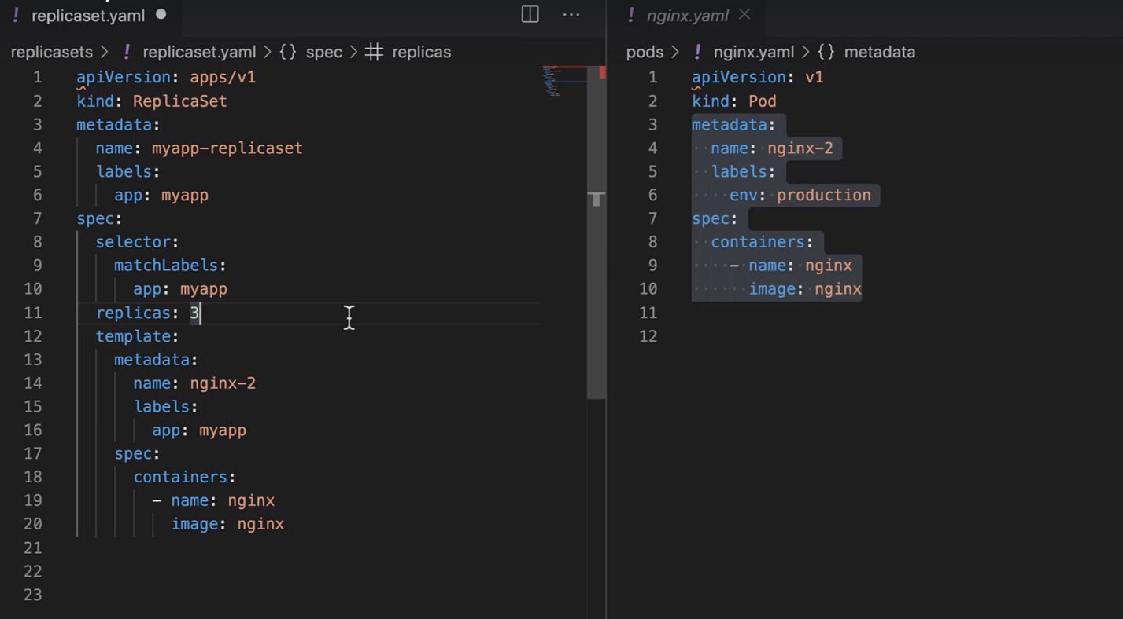

After writing the YAML file for the Replica Set use the below Kubectl command:



To check the status of the newly created Replica Set, use the below command:



To further inspect the status of the Pods, use the below command:



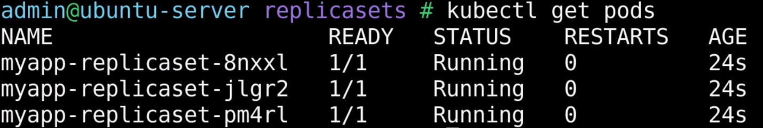

The above command shows that all of the Pods have unique name but you will notice that the name of the pod begins with the name of the replica set. That way you can look at the pod and you can identify if it is a standalone pod or a pod that is part of replica set.

If you now try to delete a pod with the below command:



And after the delete command if you try to run the get pods command again you will notice that the number of pods remains 3 and out of 3, 1 pod will be newly created. That’s the replica set, ensuring that sufficient number of pods are always available on the cluster.

If you want to get the description of the replica set, you can use the below command:



We said that a replica set ensures that a minimum number of replicas are available all the time. But what if there are a greater number of replicas than what’s required?

Let’s try to create a new pod by making use of the same label that the replica set selector uses. We will create a new pod directly and not through the replica set and we’ll see what happens when we create a new pod outside of the replica set, but one that has the same label that the replica set selector uses. For that use the below command



And if you run the Kubectl get pods command and you will see the status of the newly created pod is in terminate state. The replica set is terminating the new pod that we have created and it’s not allowing more pods with the same labels than the number of replicas configured on the replica set.

**How to update the replica set?**

What if we want to change the number of replicas to 4 instead of 3?

To do this we have to update the replica set file and set the replica count to 4. We have to use the below command:



This command will open the definition of replica set in a text editor. The file that will be opened will be a temporary file but not the file that we have created. This file is created by Kubernetes in memory to allow us to edit the configuration of an existing object on Kubernetes. And that’s why you will see lots of additional fields in this file other than the details you have provided. Under spec you can change the replica count to 4. Now Kubernetes will run the 4 pods to meet the requirements.

There’s also a command available to scale the number of replicas without having to go in and edit the definition file. Below is the command:

